**Decision Tree Intuition**

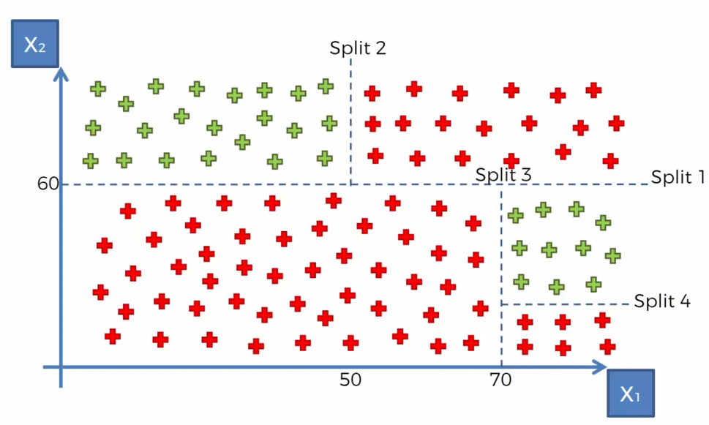

* The way Decision Tree works is, it splits out data points into multiple splits at different values of dependent and independent values.

How does the decision tree algorithm know where to split?

* If we have a look at it now, the split is done in such a way to maximize the number of certain categories in each split.
* That is a really basic way to explain it, there is some complex mathematics going on in the background – the split is trying to minimize the entropy.
* For now, we just need to know that the algorithm is going to find the optimal splits that is going to maximize the points in each pocket (leaves)
* So, in the start you have a scatter plot, and at the end you have got these leaves, and the final leaves are called terminal leaves.
* The way this model works is shown below –